Tide Activity Generator

# Overview:

The Tide Activity Generator’s purpose is to get the real estate activity for a given area over a given date range format such that it can be pasted into a Tides Newsletter Activity section. See example market activity.

## Requirements:

* Access to flexmls.com.
* Python script activity.py
* MS excel 2010
* MS Publisher 2010

## Process:

The flexmls.com supplies the needed information via custom searches “ShoresActiveAllYrToDate” and “ThePointesYrToDate”. The user runs the desired search selecting the required start and ending dates. The user selects the View drop down text box selecting “ActivityYearToDate” and via the Sort button selects “ActivitySortByStatusTypePrice”. The user may need to edit the search selecting all the status that are required( Active, Active Under Contract, Pending, and Sold ). Once the user verifies the listing data is what is desired the user selects the Export button and then:

1. Insure Export all matches is selected
2. Select “Custom Text Export” radial button and selects “TidesActivity.csv” in the drop down text box.
3. Enter the verification text
4. Click the Export button to receive data
5. When the download dialog pops up select the TODO: determine correct folder location resource folder and rename the file to either shores.csv or pointes.csv whichever is appropriate for the received data.

# Sample of Shores Market Activity:

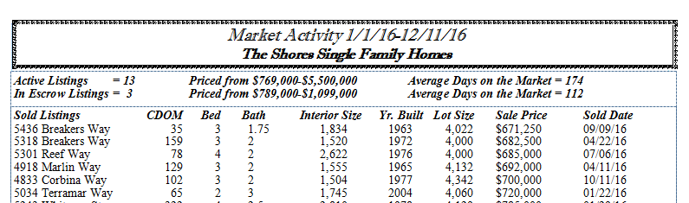

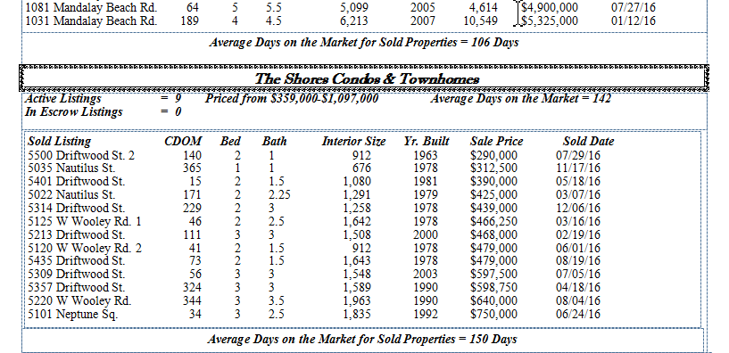

# Sample of The Pointes Market Activity:

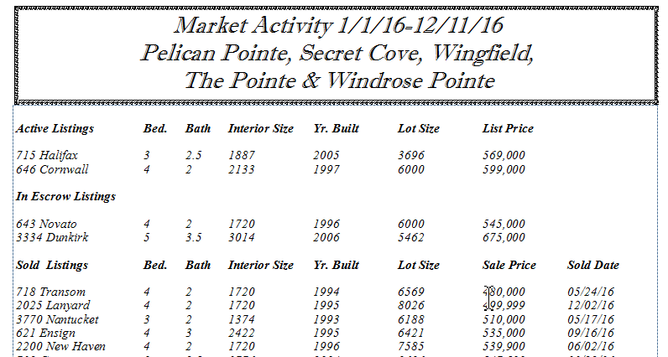

## Details:

### View:

#### Fields:

1. MLS #
2. Status = [ Active, Active – Price Reduced, Active Under Contract, Pending, Pending-Status Change, Sold, Sold-Status Change]
3. Address
4. Price
5. Property Sub-Type = [ CN, SF, TH] CN = Condon, SF = Single Family, TH = Townhome
6. CDOM
7. BD
8. T BA
9. BA F
10. BA ¾
11. BA ½
12. BA ¼
13. SqFt
14. Lot SqFt
15. Yr Blt
16. Sold Date

#### Sort: "ActivitySortByStatusTypePrice"

#### Fields:

1. Status Ascending
2. Property Sub-Type Ascending
3. Sold Price Ascending
4. Listing Price Ascending
5. Original List Price Ascending

### Search Criteria:

#### ShoresActiveAllYrToDate:

#### Search description:

Oxnard Shores map polygon for all SFR Active, Active under Contract & pending from Jan 1 2016 to now.

#### Search parameters:

Ventura County Regional Data Share, CARETS - CRIS, CARETS - CLAW, CARETS - ITECH, CARETS - PALM SPRINGS, CRMLS (historical data), California Desert; Property type Residential; Inside Oxnard Shores of Polygon; Pending Date between '1/1/2016' and '12/31/2016'; Property Sub-Type of 'Condominium', 'Single Family Residence', 'Townhouse'; Sold Date between '1/1/2016' and '12/31/2026'; Status of 'Active', 'Pending', 'Sold’, ‘Active Under Contract'.

This search uses template: 1 - Residential

#### ThePointesYrToDate:

TODO: add description